**Enhanced Recycling Sorter Using Machine Learning Techniques [CNN]**

***Abstract :*** Obtain an understanding of the fundamental operations and importance of a recycling sorter before delving into the developments in recycling sorters through the use of machine learning techniques, particularly Convolutional Neural Networks (CNN). A recycling sorter is an automated device that effectively separates different kinds of recyclable materials, like paper, glass, metals, and plastics, at waste management facilities. This sorting is essential to improving the recycling procedure, maximizing effectiveness, and raising the caliber of the repurposed resources by reducing contamination. By supporting the complex processing and recycling of trash, these systems are essential to efficient waste management and environmental protection.

**The Enhanced Recycling Sorter using Machine Learning Techniques with a Convolutional Neural Network (CNN)** is a sophisticated system that is designed to improve the sorting and separation processes in recycling facilities. By this leveraging the power of machine learning and specifically CNNs, the system can automatically classify different types of recyclable materials from a waste pile, ensuring that each type is directed to the appropriate recycling process. This technology not only increases the efficiency of recycling operations but also helps in reducing contamination in recyclable materials, which is crucial for maintaining the quality of the recycled output and health hazard world impact.

The growing global garbage dilemma necessitates creative ways to recycle waste effectively. This research suggests using convolutional neural networks (CNNs) to create and deploy an enhanced recycling sorter. By automating the sorting process and boosting recycling rates and decreasing environmental impact, the incorporation of machine learning techniques into recycling systems holds the potential to completely transform waste management. In order to promote sustainability and resource conservation, this study highlights the importance of implementing a CNN-based recycling sorter and describes its approach, problems, and implications.

This research also looks at the advantages and ramifications of using CNN-based recycling sorters globally. The emphasis is still on improving recycling procedures, but it also clarifies the wider environmental effects of waste management techniques used in various nations. Variations in consumer behavior, policies, and recycling infrastructure lead to different degrees of environmental degradation across the globe. In order to address the global trash challenge, this article emphasizes the critical need for cooperative efforts and legislative interventions by exposing the environmental effects of waste management strategies from various nations.

***Keywords:*** Recycling, Environmental Impact, Image Classification , Convolutional Neural Networks

**INTRODUCTION**

The exponential growth in global population and consumption patterns has led to a dramatic increase in waste generation, presenting unprecedented challenges to environmental sustainability and public health. The management and recycling of this burgeoning waste stream have become imperative for mitigating environmental degradation and conserving finite resources. Traditional recycling processes, reliant on manual sorting and outdated technologies, are often inefficient, labour-intensive, and prone to contamination, hindering the achievement of recycling goals.

In response to these challenges, there has been a growing interest in leveraging advanced technologies, particularly machine learning, to enhance recycling systems and streamline the sorting process. Convolutional Neural Networks (CNNs), a subset of deep learning algorithms, have demonstrated remarkable capabilities in image recognition tasks, making them well-suited for automated material identification and sorting in recycling facilities.

While the adoption of machine learning techniques in recycling systems holds immense promise, its successful implementation requires collaboration and coordination among stakeholders at both local and global levels. Waste management practices vary significantly across countries, influenced by factors such as economic development, infrastructure, regulatory frameworks, and cultural attitudes towards recycling. Developed nations often boast sophisticated recycling infrastructure and stringent regulations, leading to higher recycling rates and better waste management practices. Conversely, developing nations may face challenges such as inadequate infrastructure, limited resources, and insufficient regulatory enforcement, resulting in higher levels of waste mismanagement and environmental pollution.

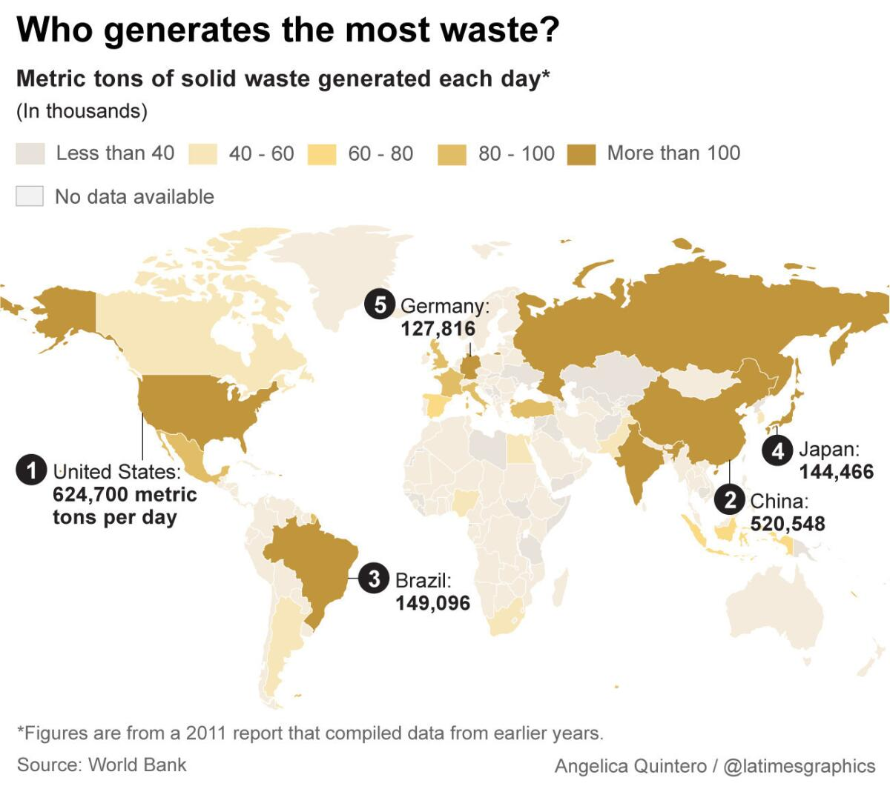

Figure 1: Countries generates the most waste !

The involvement of different countries in waste management and recycling is multifaceted, encompassing various aspects ranging from waste generation and collection to processing and recycling. Developed countries, including the United States, European Union member states, Japan, and South Korea, have made significant investments in recycling infrastructure, technology innovation, and public awareness campaigns, leading to commendable progress in waste management and recycling. These countries often serve as pioneers in adopting advanced recycling technologies, including CNN-based sorting systems, and serve as role models for others to emulate.

Conversely, developing countries, particularly those in South Asia, Africa, and Latin America, grapple with mounting challenges in managing escalating waste volumes amidst resource constraints and socio-economic disparities. In these regions, informal recycling sectors often play a crucial role in waste collection and processing, albeit under precarious working conditions and without adequate regulatory oversight. The adoption of advanced recycling technologies, including CNN-based sorting systems, presents an opportunity to enhance the efficiency and sustainability of waste management practices in these countries while addressing pressing environmental and social concerns.

In light of the diverse challenges and opportunities associated with waste management and recycling across different countries, this paper seeks to explore the development and implementation of an Enhanced Recycling Sorter using CNNs. By examining the involvement of various countries in waste management practices and highlighting disparities in recycling infrastructure, policies, and consumer behaviours, this paper aims to underscore the importance of global collaboration and knowledge sharing in addressing the global waste crisis. Moreover, it seeks to elucidate the potential benefits of deploying CNN-based recycling sorters in diverse socio-economic contexts, with a view towards promoting environmental sustainability and resource conservation on a global scale.

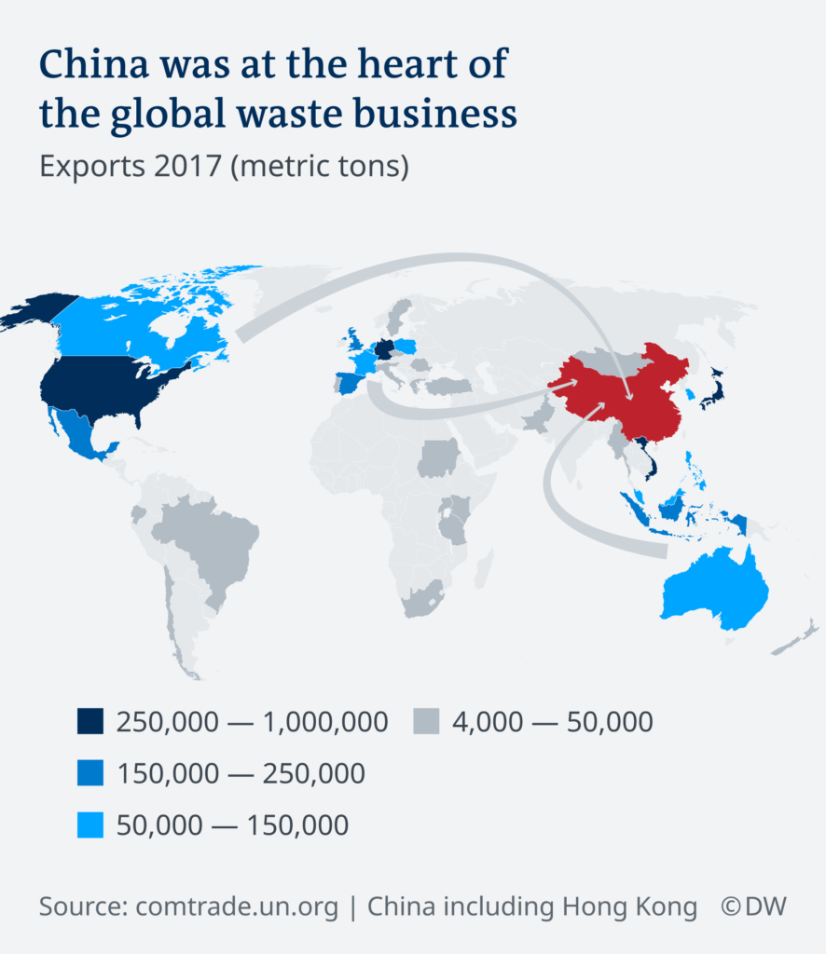

Figure 2: in 2017 China was the recycling Sorter

China was the center of the world's garbage industry in 2017, acting as the main hub for large amounts of recyclable materials coming from all over the globe. It was vital to the worldwide recycling sector since it was the biggest importer of used paper, plastics, metals, and other recyclables. However, when China launched its "National Sword" campaign that year, this situation drastically changed. This policy crackdown placed strict quality standards and contamination limitations on imported recyclables in an effort to combat unlawful and subpar solid waste imports. As a result, China raised the threshold for the quality of materials allowed for imports and effectively prohibited several kinds of waste, which caused major disruptions in the worldwide waste trade.

The implications of China's policy change were felt throughout the world, causing a crisis in the recycling sector and forcing exporting nations to reevaluate their approaches to waste management. Restrictions on traditional export routes made it difficult for nations like the UK to manage excess recyclables and compelled them to look for other ways to dispose of garbage. The disruption prompted a global push for the circular economy and a reassessment of home trash management procedures and recycling infrastructure. The outcome was a significant shift in the global trash industry's landscape, emphasizing the interdependence of waste flows and the necessity of resilient and sustainable waste management systems.

This below image presents data on waste management practices across various countries and regions, showcasing the percentages of waste recycled/composted, sent to waste-to-energy (WTE) and disposal facilities, landfilled, and managed through other methods.

The data is represented through horizontal bar charts, with each bar segmented into four colours: green for recycling and composting, red for WTE and disposal facilities, yellow for landfilling, and blue for other methods. Switzerland stands out with the highest recycling and composting rate, while countries like Bolivia and Colombia heavily rely on landfilling for waste disposal. Developed nations such as those in Western Europe and Singapore generally have higher rates of recycling/composting and WTE utilization compared to developing countries, which tend to have higher landfilling percentages.

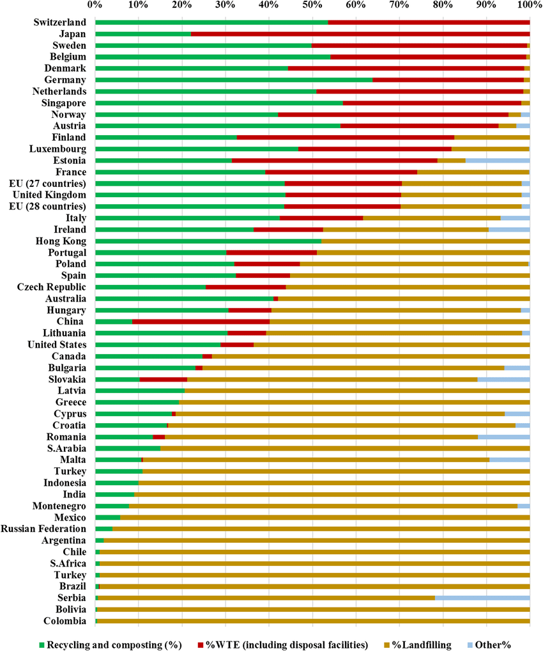

Figure 3 : Waste Management Practices Across Countries and Regions

**LITERATURE REVIEW**

**1.** **Self-Adaptive Waste Management System: Utilizing Convolutional Neural Networks for Real-Time Classification by Siddhartha Bhattacharya, Ashwin Kuma:** The authors propose a self-adaptive system capable of dynamically adjusting its classification algorithms based on real-time feedback, thereby enhancing sorting accuracy and efficiency. The use of CNNs enables the system to autonomously identify and segregate different types of waste materials, such as plastics, paper, glass, and metals, with high precision. By leveraging machine learning techniques, the proposed system offers a scalable and adaptable solution to the challenges of modern waste management, including increasing waste volumes and contamination levels. The paper contributes to the existing literature by demonstrating the potential of CNNs in revolutionizing waste sorting processes and advancing sustainability goals. However, further research is needed to validate the system's performance in real-world settings and optimize its deployment for widespread implementation in waste management facilities.

2. **Deep Learning Approach to Recyclable Products Classification: Towards Sustainable Waste Management by Ahmed, Rahman, Mustafa :** Presents a novel application of deep learning techniques to address the challenges of recyclable products classification, with the ultimate goal of advancing sustainable waste management practices. Through the utilization of deep learning models, particularly Convolutional Neural Networks (CNNs), the authors demonstrate the effectiveness of their approach in accurately classifying various recyclable materials, including plastics, paper, glass, and metals. The study showcases promising results in terms of classification accuracy and efficiency, offering a potential solution to the complexities associated with waste sorting processes. By leveraging advanced technologies, the paper contributes to the discourse on sustainable waste management by proposing a scalable and adaptable solution that has the potential to streamline recycling operations and reduce environmental impact.

Moreover, the paper underscores the importance of technological innovation in addressing the challenges posed by increasing waste volumes and contamination levels, particularly in the context of growing environmental concerns and resource depletion. By harnessing the power of deep learning algorithms, the authors offer a data-driven approach to recyclable products classification that has implications for improving recycling efficiency, reducing landfill waste, and promoting circular economy principles. The findings of the study have implications for waste management stakeholders, including policymakers, waste management practitioners, and industry professionals, highlighting the potential of deep learning techniques to revolutionize waste management practices and contribute to the realization of sustainability goals. Overall, the paper represents a significant contribution to the field of sustainable waste management and sets the stage for further research and innovation in this critical area.

3. **Life Cycle Sustainability Assessment of Single Stream and Multi-Stream Waste Recycling Systems by Hoa Zhang, Delawter, Wolfe :** provides a comprehensive evaluation of the sustainability implications associated with single-stream and multi-stream waste recycling systems. Through a life cycle sustainability assessment (LCSA) framework, the authors analyze environmental, social, and economic factors across different stages of waste management, from collection and sorting to processing and disposal. The study reveals nuanced differences between single-stream and multi-stream systems, highlighting trade-offs in terms of resource efficiency, contamination rates, operational costs, and community engagement. By considering multiple dimensions of sustainability, the paper offers valuable insights for policymakers, waste management practitioners, and stakeholders to make informed decisions regarding waste management strategies and infrastructure investments.

Moreover, the paper contributes to the existing literature by addressing the complexity of waste management systems and their broader sustainability implications. By adopting a holistic approach that integrates environmental, social, and economic considerations, the study provides a nuanced understanding of the trade-offs and synergies associated with different waste recycling approaches. The findings underscore the importance of context-specific solutions and the need for tailored strategies to optimize sustainability outcomes based on local conditions, infrastructure capacities, and stakeholder preferences. Overall, the paper serves as a valuable resource for advancing the discourse on sustainable waste management practices and guiding decision-making processes towards more resilient and equitable waste management systems.

4. **Cost-benefit analysis of waste reduction in developing countries: A simulation by Ricardo Diaz and Suehiro Otoma :** Offers a thorough examination of the economic implications of waste reduction initiatives in developing countries through a cost-benefit analysis framework. By utilizing simulation techniques, the authors model various waste reduction scenarios and assess their financial feasibility, considering factors such as investment costs, operational expenses, and potential cost savings. The study provides valuable insights into the economic viability of waste reduction measures, shedding light on the potential returns on investment and long-term sustainability benefits. Through its rigorous analysis, the paper contributes to bridging the gap in empirical research on waste management economics in developing countries and offers practical guidance for policymakers, businesses, and community organizations seeking to implement effective waste reduction strategies.

Furthermore, the paper addresses a pressing issue in the context of sustainable development by emphasizing the importance of waste management in mitigating environmental pollution, conserving resources, and promoting economic prosperity in developing countries. By quantifying the costs and benefits of waste reduction interventions, the study underscores the potential for win-win outcomes, wherein investments in waste reduction yield positive returns not only in terms of environmental and social outcomes but also in economic terms. The findings of the paper provide a compelling case for prioritizing waste reduction efforts and allocating resources efficiently to maximize the overall welfare of communities in developing countries

**METHODOLOGY**

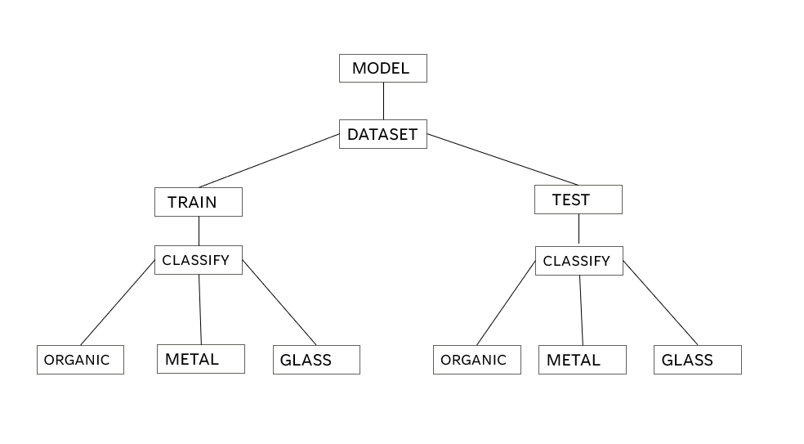

Figure 4: Flow Diagram of the Model

Above Flow chart is the visual representation of the project that we take the Model [MobileVnet Model] CNN Model and We have a Dataset, From that we train and test the Dataset. it will classify the waste management and tell us what the waste is, and then we separate which can be recycled or which cannot be recycled

**VGG – 16 CNN MODEL:**

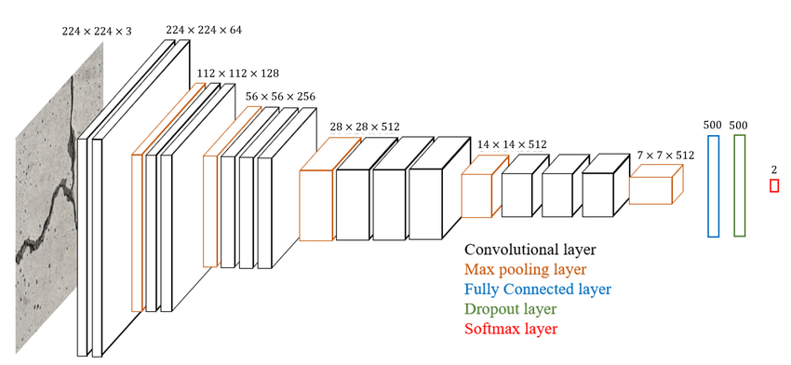

Figure 5: VGG-16 Architecture

**VGG16 Model:**

The VGG16 model is a significant architecture in the domain of convolutional neural networks, primarily renowned for its simplicity and profound impact on the field of deep learning. Developed by the Visual Graphics Group (VGG) at Oxford, this model was introduced to enhance image recognition capabilities. It features a deep network with 16 layers that are trainable, including thirteen convolutional layers and three fully connected layers, all followed by activation layers using the ReLU function. This architecture is straightforward in that it consistently uses 3x3 convolutional filters with a stride of 1 and pads the input to preserve spatial resolution, and max pooling is used to reduce dimensionality throughout the network. This systematic approach allows the VGG16 model to effectively learn from a vast array of image data, making it excellent for tasks that involve classifying and processing visual information.

VGG16’s true prowess is demonstrated in its application across various real-world scenarios, where it serves as a pre-trained model that can be fine-tuned to specific, less generic tasks. In areas ranging from facial recognition to autonomous driving, VGG16 provides a robust framework for feature extraction. The depth of the network allows it to capture complex patterns in large-scale data, which is invaluable for systems requiring high accuracy in object and pattern recognition. Moreover, due to its architecture's uniformity and the availability of pre-trained weights, VGG16 can be easily adapted to new problems without the need for training from scratch, making it a preferred choice for many machine learning practitioners looking to implement effective solutions quickly.

Despite its widespread adoption, the VGG16 model comes with certain limitations, primarily its size and computational inefficiency. The model is quite large, consuming substantial memory and computational resources, which can be a hurdle in deploying applications that require real-time processing. Additionally, the deeper network structure, while beneficial for complex pattern recognition, also makes it prone to overfitting when not managed correctly, especially in cases with limited training data. These challenges necessitate careful consideration and management of resources when integrating VGG16 into new projects. However, its ability to be fine-tuned with transfer learning and its strong performance on various visual recognition tasks continue to make it a valuable tool in the arsenal of machine learning models.

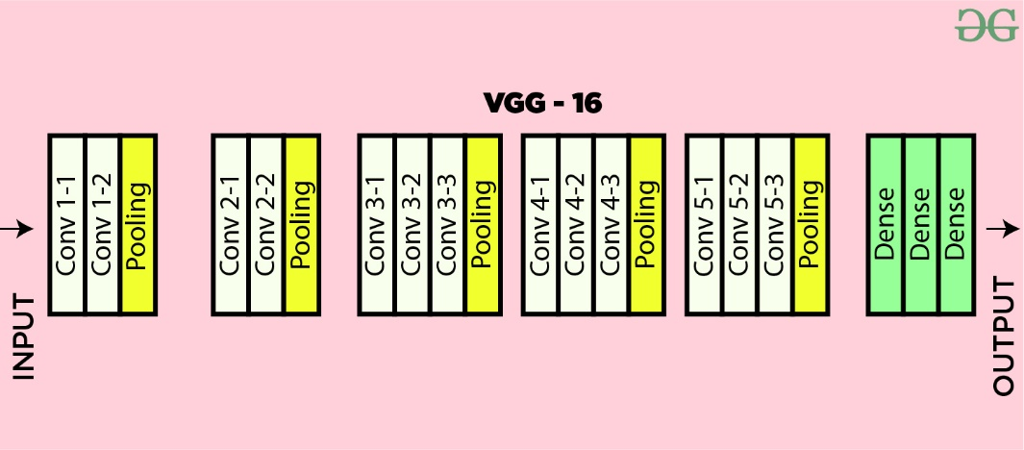

**DATASET:**

We have taken the dataset from the Kaggle which has 24,705 photos of solid household waste are included in the dataset, which is divided into two classes: recyclable (10,825) and organic (13,880). The dataset is an updated and reorganized version of Sashaank Sekar's original work, which can be accessed at https://www.kaggle.com/techsash/waste-classification-data. There are 25,077 photos of organic (13,966) and recyclable (11,111) photographs in the original Kaggle dataset. To get the data down to 24,705 with (13,880 organic) and (10,825 recyclable), several cleanup operations were carried out, as detailed in the "further note". Researchers and academics from Edge Hill University's Computer Science Department in the United Kingdom have used the reconstructed data in a study.

The dataset is organized into two categories: organic waste and recyclable waste, with an allocation of 85% for training and 15% for testing. The training set comprises 22,564 images, providing a rich base for the model to learn from. Conversely, the testing set includes 2,513 images, which will be used to evaluate the model's effectiveness in accurately classifying the waste types. This structure allows for comprehensive training and robust testing to ensure the model's reliability in distinguishing between organic and recyclable waste.

<https://www.kaggle.com/datasets/techsash/waste-classification-data>

**Testing and Training the Dataset with the created Model**

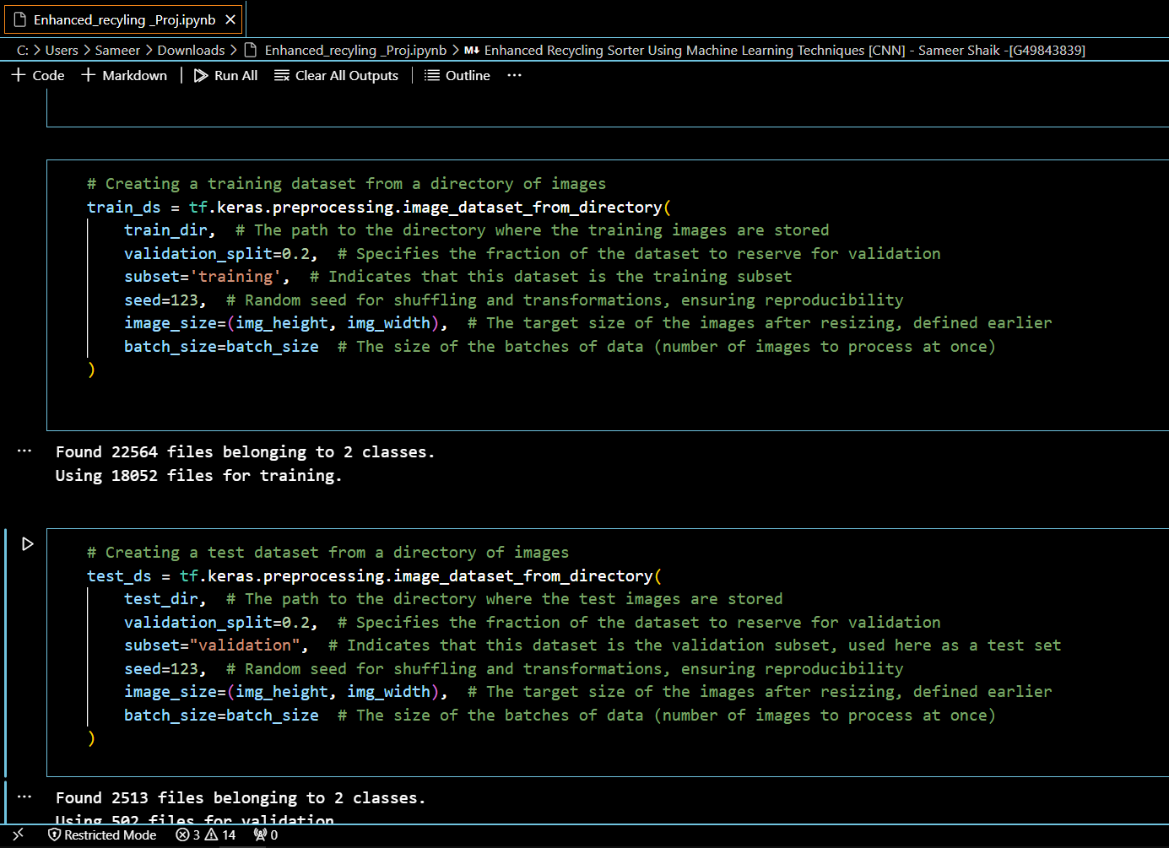

First part creates a training dataset, and the second part creates a test dataset. In the first part, the tf.keras.preprocessing.image_dataset_from_directory function is used to automatically load and preprocess images from a specified directory (train_dir). It configures the dataset to use 80% of the images for training, setting aside 20% for validation as indicated by the validation split=0.2. The images are resized to 64x64 pixels, and batches of 32 images each are prepared for processing.

Second part of the code handles the test dataset setup in a similar manner but uses the 'validation' subset of the images. This implies that the dataset initially prepared for validation is now being used for testing the model, which is a common practice for evaluating model performance after training. The results show that the dataset contains 22,564 files, categorized into two classes. Of these, 18,052 files are used for training, ensuring a substantial amount of data for training the model to classify types of waste, likely aimed at improving recycling processes. The clear, structured comments in the code enhance understanding and reproducibility of the setup for anyone reviewing this work.

**Model summary of the Created Model**

Creating the Model using the Convutional Neural Network and this is the Model 1 and down is the summary of the model1 Output can see in my ipynb file attached

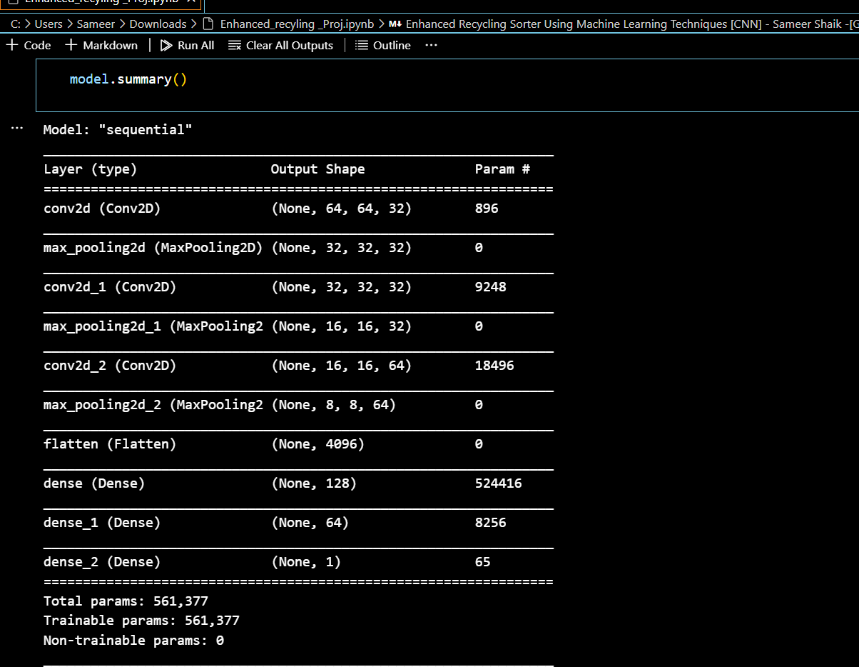

Figure 6: Created Model Summary

**Training the Model with the 30 epochs**

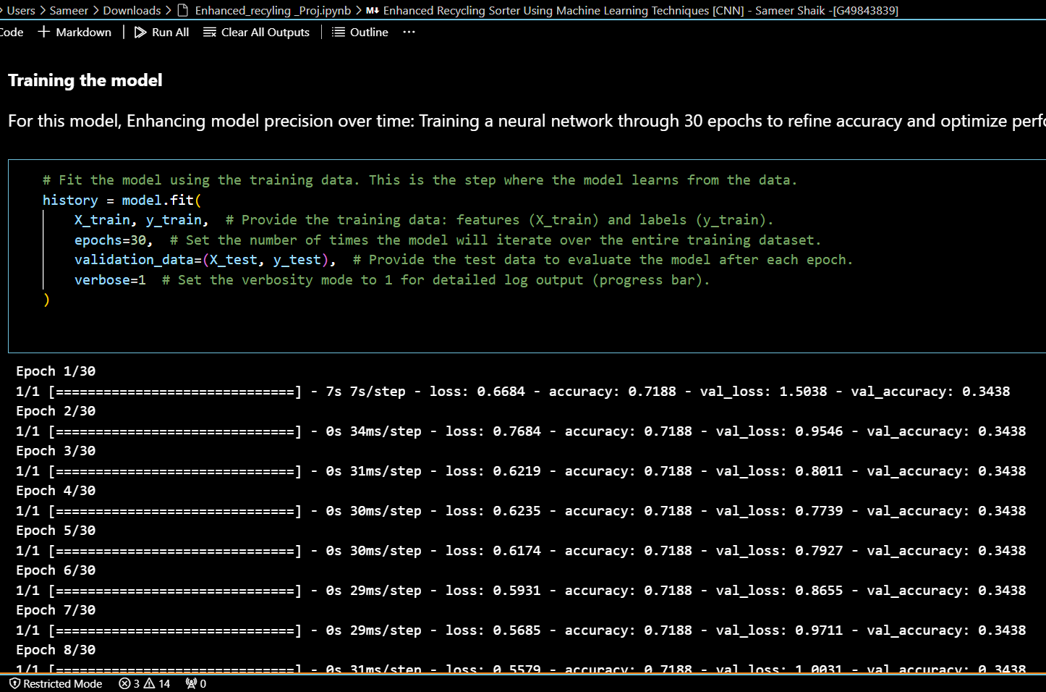

Figure 7: Model 1 Output as above

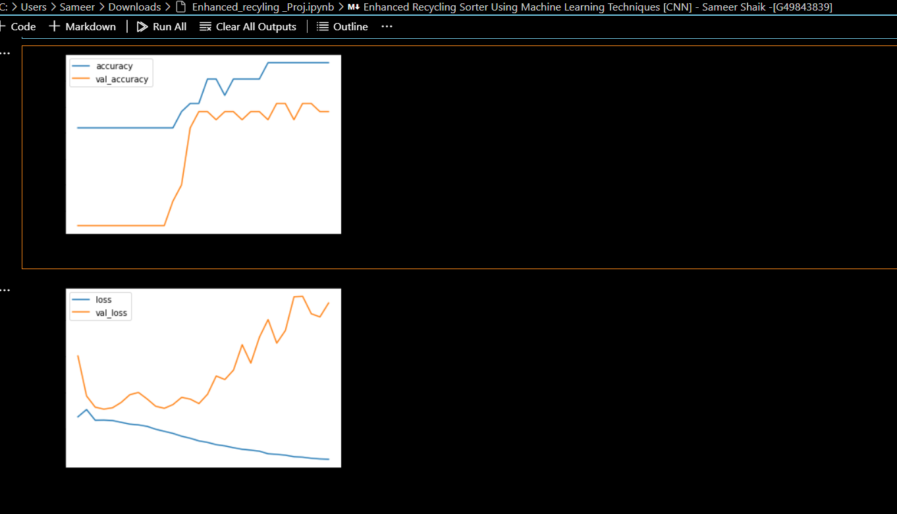

Figure 8: Accuracy of Testing and Training for Model 1

The Above plots clearly show a significant disparity in accuracy between the training and validation datasets, indicating overfitting. While the training accuracy continues to rise, the validation accuracy plateaus at 78%. This scenario suggests challenges in achieving high accuracy using a CNN that has been built from scratch with this particular dataset. Training Accuracy: 0.9688

Testing Accuracy: 0.7812

**Model 2:**

In our second model iteration, we're incorporating extra convolution layers and simplifying the architecture of the fully connected layers to enhance accuracy. Additionally, we're integrating Dropout layers to combat overfitting during training, aiming for a more robust model performance.

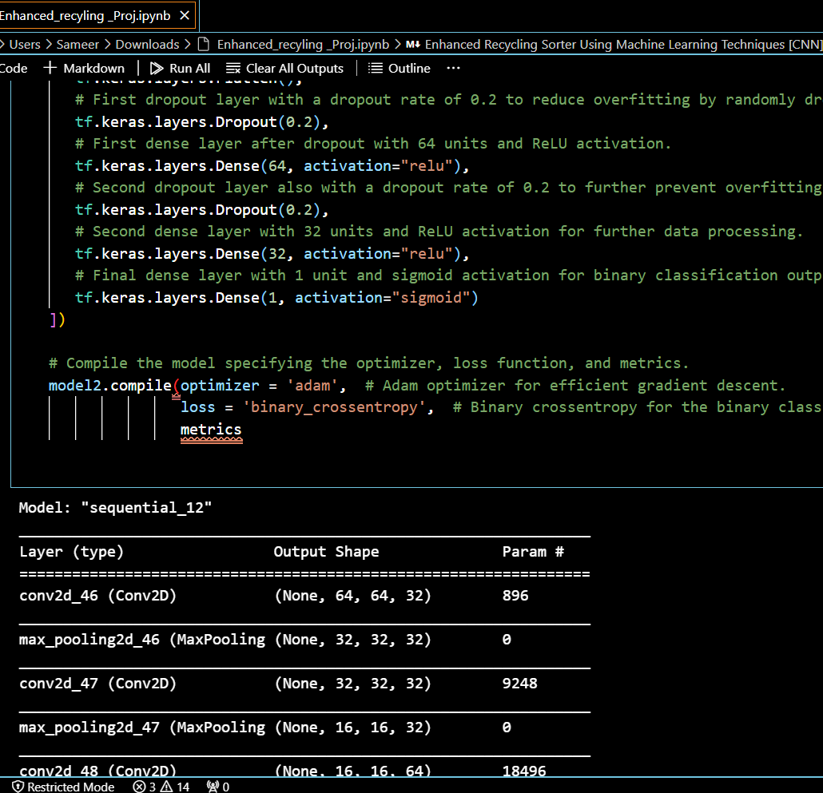

Figure 9: Model 2

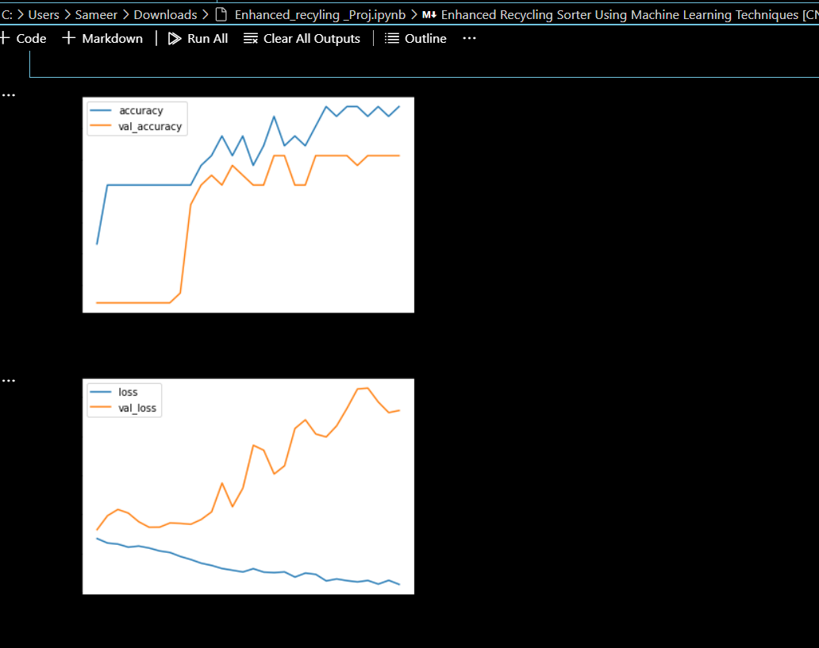

Figure 10: : Accuracy of Testing and Training for Model 2

Training Accuracy: 0.9688

Testing Accuracy: 0.8125

The validation accuracy is achieved 81% in the training process.

The training accuracy is increasing over time, whereas validation accuracy stalls around 80% in the training process. We also see that the overfitting slightly decreased. The validation loss reaches a minimum value after 5 epochs, and then stabilizes, with the training loss decreasing linearly until the values are close to 0.

**Model 3:**

**We also may add Batch Normalization to reduce overfitting.**

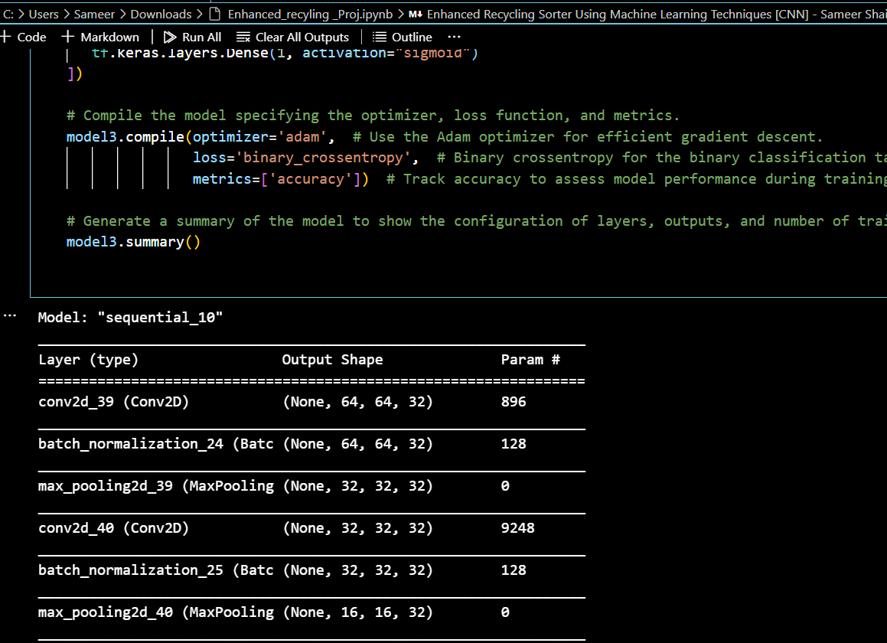

Figure 11: Model 3

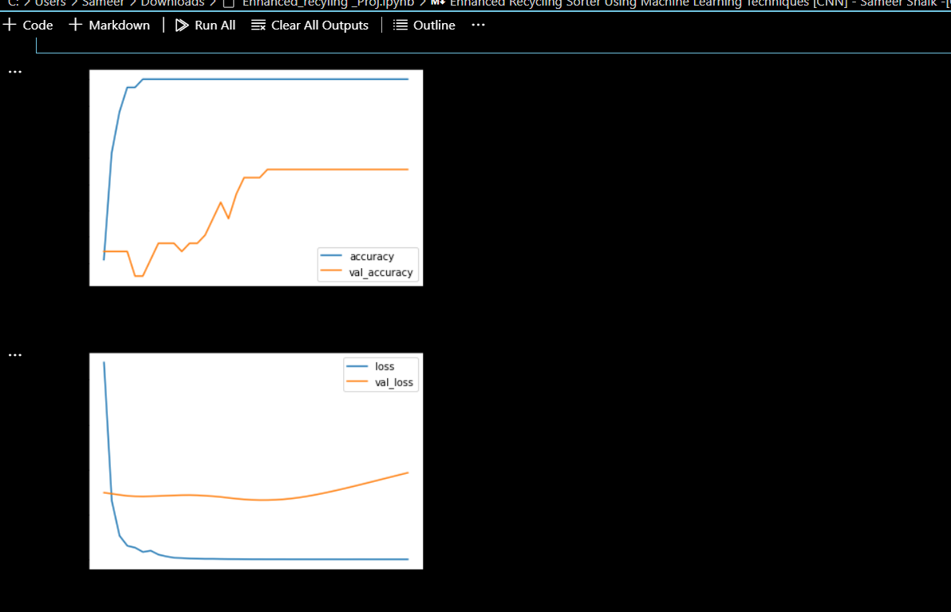

Figure 12: : Accuracy of Testing and Training for Model 3

Testing Accuracy: 0.6562

In this case, the highest validation accuracy reached during training was only 65%. While the training accuracy continued to improve, the validation accuracy plateaued at 65%. Regrettably, this indicates a substantial increase in overfitting**.**

**Conclusion:**

The first model is structured with three convolutional blocks, each complemented by a max pooling layer. It features a fully connected section consisting of three dense layers, with the initial two layers activated by a generic activation function and the final one by a sigmoid activation function. This configuration resulted in a training accuracy of 96.88% and a testing accuracy of 78.12%.

In the second model iteration, additional convolution layers were incorporated, and the architecture of the fully connected layer was simplified to enhance overall accuracy. Moreover, dropout layers were introduced to address overfitting observed during the training process. These adjustments maintained the training accuracy at 96.88% while improving the testing accuracy to 81.25%.

Despite integrating batch normalization in the third model to curb overfitting, it demonstrated the least effectiveness among the three, with a testing accuracy of just 65.62%. Although batch normalization typically helps in maintaining a consistent scale of activation, it was not sufficient in this case. The second model clearly outperforms the others, showcasing a superior ability to generalize from the training data as evidenced by the accuracy figures and graph plots.

It seems Model 2 is outperforming the others in accuracy with your dataset, indicating its superior ability to capture based on the above graph plots. Though I have used the normalization for overfitting to combat overfitting in Model 3, it still exhibits signs of overfitting.

SAMEER SHAIK

G49843839